INVENTORY MANAGEMENT

SYSTEM

Introduction: An inventory management system is the process by which you track your goods throughout your entire supply chain, from purchasing to production to end sales. It governs how you approach inventory management for your business.

We need an inventory system Any STORE that handles stock will need a system to track and control it. You’ll quickly run into situations where your business is overstocked or understocked. So in this inventory system we can keep a track of our stock on certain products.

USER ANALYSIS

We’ve spoken to people who use software similar to our topic. Though they feel it to be satisfactory they did give us some suggestions like an option to view the user’s current NET INVENTORY VALUE and we are planning on adding it on our webpage using a floating status bar on the top of the page and so on. we’ve also made our page more user friendly than the software’s which we’ve observed in our survey.

REQUIERMENTS

Front end: Html, css, javascript

Backend: php files, Database

LOGIN PAGE

In this page we’ll have to login and enter the required credential. If the user is new to the page then he can click on the SIGN UP button.

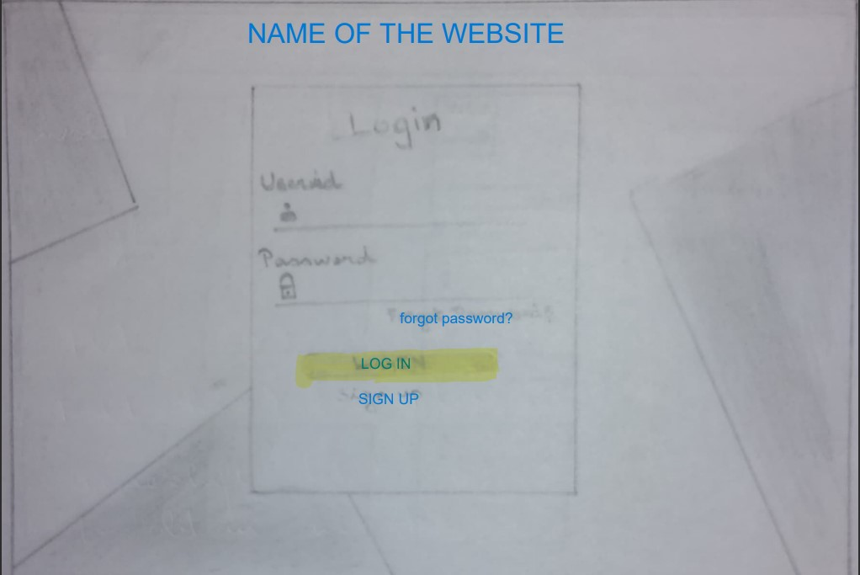

**HOME PAGE**

**In** this page we’ll be able to see all the products which are low in stock and at the right corner of the webpage we have two options 1)its dispalys our profile image and log out button to log out.

2) There’s a notification button to give the user important messages

We have a floating status bar which displays the net value of the user’s stock when you click on it the user get’s redirected to the profile page .

Then we have the HELP and FAQ OPTIONS where if the user is unable to find something or has any queries can visit to that HELP page then the

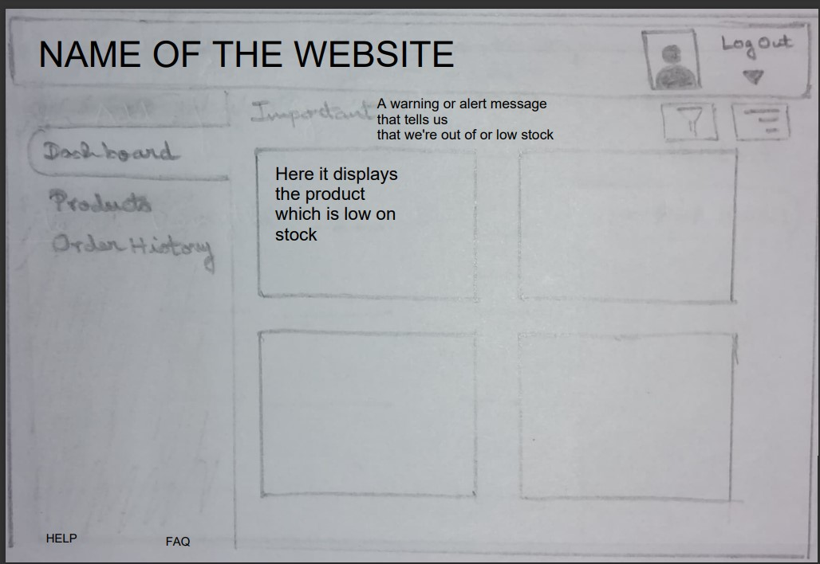

PRODUCTS PAGE

In this page the product details are displayed where there is even an option where we can either edit or REMOVE a product when you click On a certain product.

When you click on a product you’ll be redirected to another page where the user will be able to view a detailed information on the product and also a graph which displays

The current stock available, according to the date and time.

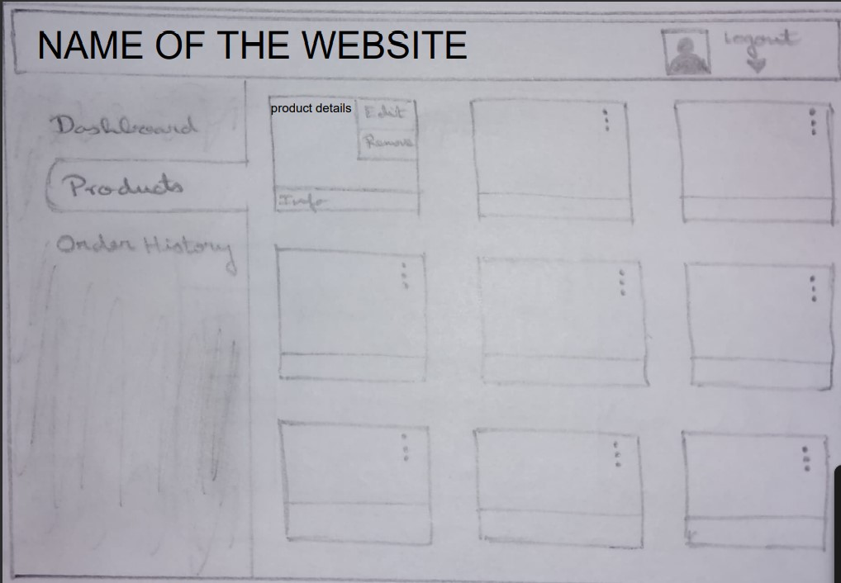

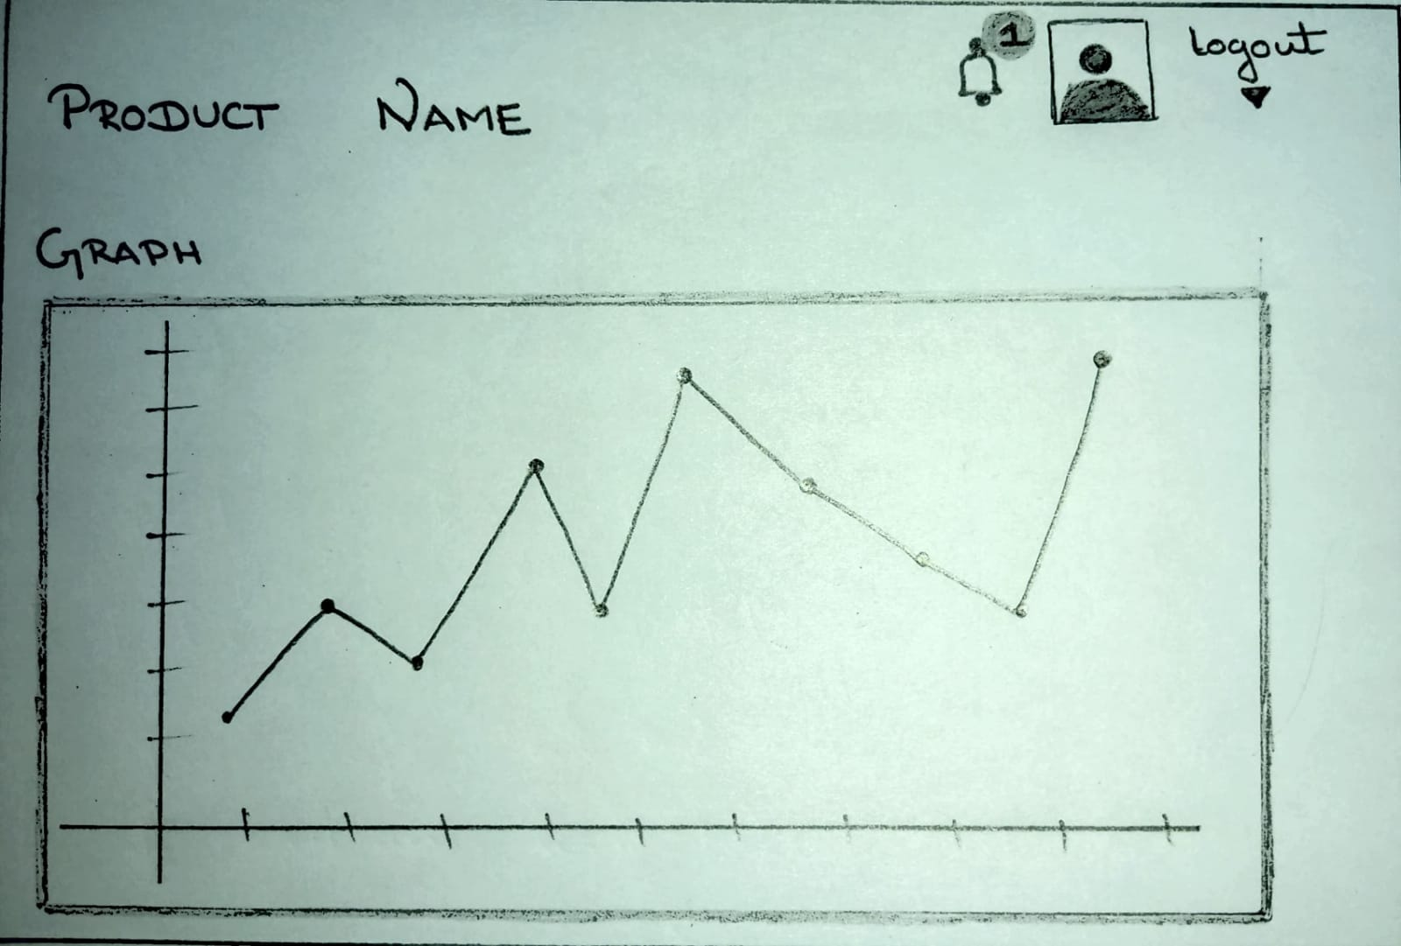

**ORDER HISTORY**

In this page the user will be able to view all transactions made by him and to see how much stock he had bought .

Here the user can view DATE, TIME, PRODUCT, QUANTITY.

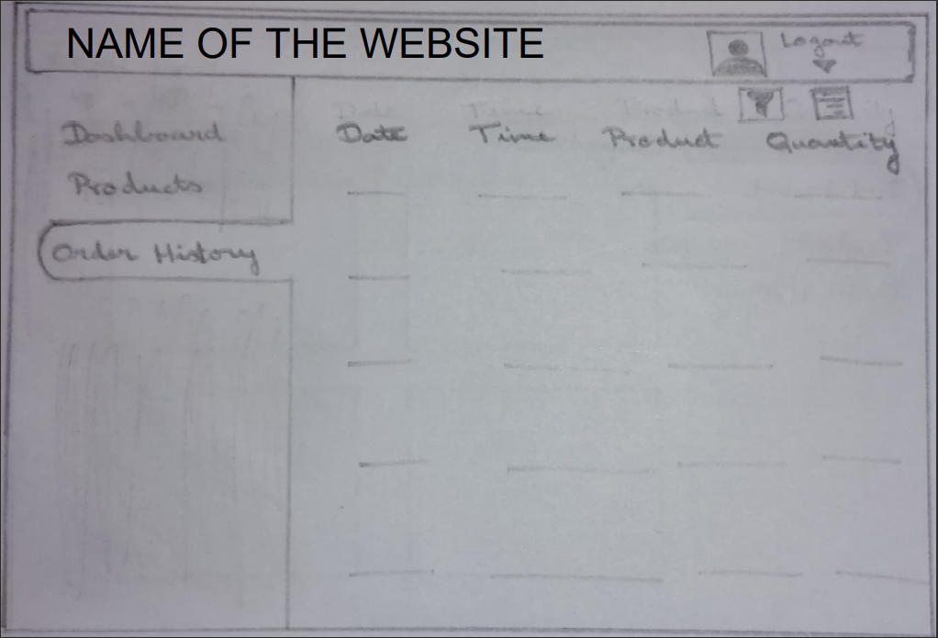

**PROFILE PAGE**

In this page the user can view his personal details and the net value with a graph to overview his progress.

